1.–/5 pointsLarCalc11 2.4.013.
My NotesAsk Your Teacher
Find the derivative of the function.
h(s) = −2
7s² + 5
h'(s) =
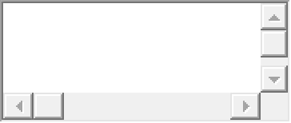


2.–/5 pointsLarCalc11 2.4.027.
My NotesAsk Your Teacher
Find the derivative of the function.
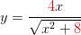
y'(x) =


3.–/5 pointsLarCalc11 2.4.037.
My NotesAsk Your Teacher
Find the derivative of the trigonometric function.
g(x) = 6 tan(4x)
g'(x) =

4.–/5 pointsLarCalc11 2.5.010.
My NotesAsk Your Teacher
Find dy/dx by implicit differentiation.
dy/dx =

5.–/5 pointsLarCalc11 2.5.025.
My NotesAsk Your Teacher
Find dy/dx by implicit differentiation. Then find the slope of the graph at the given point.
xy = 7, (-7, -1)
dy
dx
=

At (-7, -1): y' = | 
6.–/5 pointsLarCalc11 2.5.055.
My NotesAsk Your Teacher
Find an equation of the tangent line to the graph at the given point.
x
+
y
= 3, (4, 1)
y =

Use a graphing utility to graph the equation and the tangent line in the same viewing window.
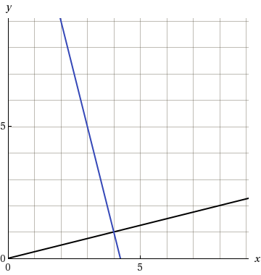

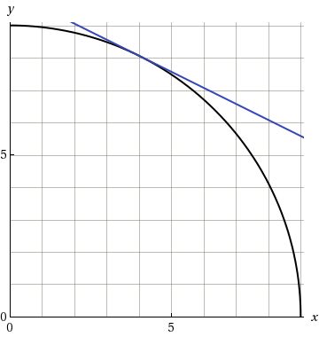

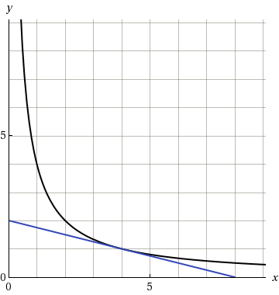

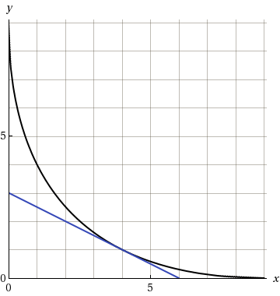
7.–/5 pointsLarCalc11 2.6.007.
My NotesAsk Your Teacher
A point is moving along the graph of the given function at the rate
dx/dt.
Find
dy/dt
for the given values of x.
y = 2x² + 3;
dx
dt
= 2 centimeters per second
(a)
x = −1
cm/sec
(b)
x = 0
cm/sec
(c)
x = 1
cm/sec
8.–/5 pointsLarCalc11 2.6.011.
My NotesAsk Your Teacher
The radius r of a circle is increasing at a rate of 7 centimeters per minute. Find the rate of change of the area when r = 33 centimeters.

cm²/min
9.–/5 pointsLarCalc11 2.6.017.MI.
My NotesAsk Your Teacher
At a sand and gravel plant, sand is falling off a conveyor and onto a conical pile at a rate of 4 cubic feet per minute. The diameter of the base of the cone is approximately three times the altitude. At what rate is the height of the pile changing when the pile is 22 feet high? (Hint: The formula for the volume of a cone is
V =
1
3
πr²h.)
h' =

ft/min
10.–/5 pointsLarCalc11 2.4.076.
My NotesAsk Your Teacher
Consider the following.
Function |  | Point
y = cos 3x |  | , −
  π
  4
  2
  2
(a) Find an equation of the tangent line to the graph of the function at the given point. (Let x be the independent variable and y be the dependent variable.)

(b) Use a graphing utility to graph the function and its tangent line at the point.
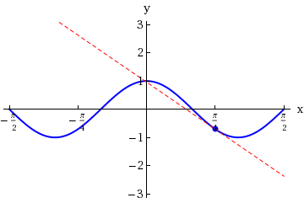 | 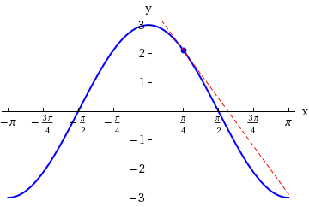
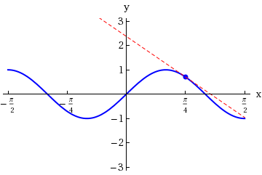 | 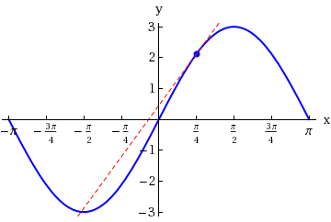

Submit AssignmentSave Assignment Progress
HomeMy Assignments

